**Question 1**: a slight deviation has been added to the angle by adding the loop’s **i** value to the x value in the rotation matrix. The code to achieve the following was very small (around 10 lines).



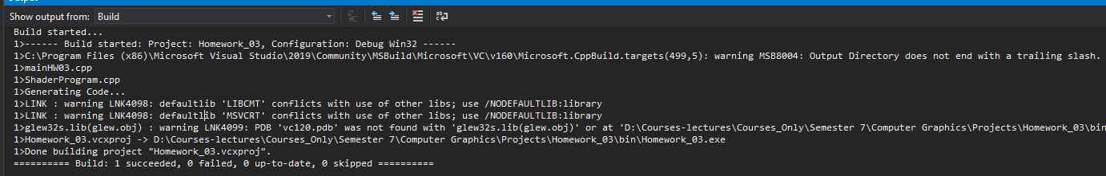

**Question 2**: $transformation=\left(\begin{matrix}1 & 0 & 0 & -1.5 \\ 0 & 1 & 0 & -1.5 \\ 0 & 0 & 1 & 0 \\ 0 & 0 & 0 & 1\end{matrix}\right)∙\left(\begin{matrix}0.5 & 0 & 0 & 0 \\ 0 & 0.5 & 0 & 0 \\ 0 & 0 & 0.5 & 0 \\ 0 & 0 & 0 & 1\end{matrix}\right)=\left(\begin{matrix}0.5 & 0 & 0 & -1.5 \\ 0 & 0.5 & 0 & -1.5 \\ 0 & 0 & 0.5 & 0 \\ 0 & 0 & 0 & 1\end{matrix}\right)$

**Question 3**: Please note that the outputs of the calculations are not normalized

$$fwd^{→}=normalize\left(eye^{→}-target^{→}\right)=normalize\left(\left[\begin{matrix}0 \\ 2 \\ 1\end{matrix}\right]-\left[\begin{matrix}0 \\ 0 \\ 0\end{matrix}\right]\right)$$

$$side^{→}=normalize\left(-fwd^{→}×\left[\begin{matrix}0 \\ 1 \\ 0\end{matrix}\right]\right)$$

$$up^{→}=normalize(side^{→}×-fwd^{→})$$

$$M=\left(\begin{matrix}side_{x}^{→} & side_{y}^{→} & side_{z}^{→} & -\left(side^{→}∙eye^{→}\right) \\ up_{x}^{→} & up_{y}^{→} & up_{z}^{→} & -\left(up^{→}∙eye^{→}\right) \\ -fwd_{x}^{→} & -fwd_{y}^{→} & -fwd_{z}^{→} & -\left(-fwd^{→}∙eye^{→}\right) \\ 0 & 0 & 0 & 1\end{matrix}\right)$$

The following will be the outputs I have obtained from previous equations (normalize() function was not applied)

$$fwd^{→}=\left[\begin{matrix}0 \\ 2 \\ 1\end{matrix}\right]$$

$$side^{→}=\left[\begin{matrix}1 \\ 0 \\ 0\end{matrix}\right]$$

$$up^{→}=\left[\begin{matrix}0 \\ 1 \\ -2\end{matrix}\right]$$

$$M=\left(\begin{matrix}1 & 0 & 0 & 0 \\ 0 & 1 & -2 & 0 \\ 0 & -2 & -1 & 5 \\ 0 & 0 & 0 & 1\end{matrix}\right)$$